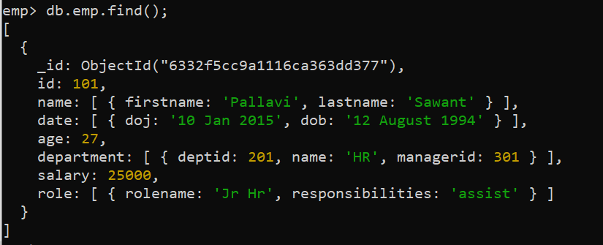

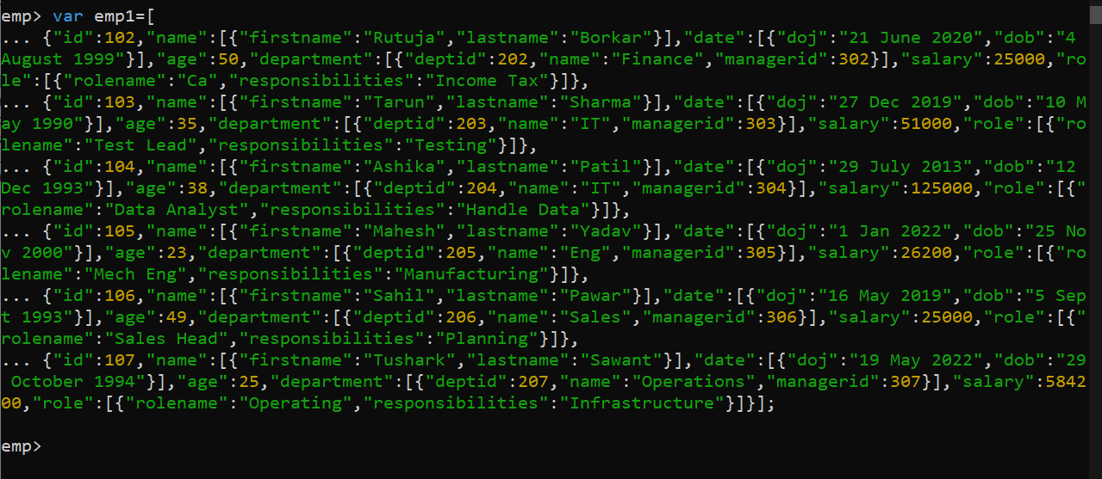

db.emp.insert({"id":101,"name":[{"firstname":"Pallavi","lastname":"Sawant"}],"date":[{"doj":"10 Jan 2015","dob":"12 August 1994"}],"age":27,"department":[{"deptid":201,"name":"HR","managerid":301}],"salary":25000,"role":[{"rolename":"Jr Hr","responsibilities":"assist"}]});

var emp1=[

{"id":102,"name":[{"firstname":"Rutuja","lastname":"Borkar"}],"date":[{"doj":"21 June 2020","dob":"4 August 1999"}],"age":50,"department":[{"deptid":202,"name":"Finance","managerid":302}],"salary":25000,"role":[{"rolename":"Ca","responsibilities":"Income Tax"}]},

{"id":103,"name":[{"firstname":"Tarun","lastname":"Sharma"}],"date":[{"doj":"27 Dec 2019","dob":"10 May 1990"}],"age":35,"department":[{"deptid":203,"name":"IT","managerid":303}],"salary":51000,"role":[{"rolename":"Test Lead","responsibilities":"Testing"}]},

{"id":104,"name":[{"firstname":"Ashika","lastname":"Patil"}],"date":[{"doj":"29 July 2013","dob":"12 Dec 1993"}],"age":38,"department":[{"deptid":204,"name":"IT","managerid":304}],"salary":125000,"role":[{"rolename":"Data Analyst","responsibilities":"Handle Data"}]},

{"id":105,"name":[{"firstname":"Mahesh","lastname":"Yadav"}],"date":[{"doj":"1 Jan 2022","dob":"25 Nov 2000"}],"age":23,"department":[{"deptid":205,"name":"Eng","managerid":305}],"salary":26200,"role":[{"rolename":"Mech Eng","responsibilities":"Manufacturing"}]},

{"id":106,"name":[{"firstname":"Sahil","lastname":"Pawar"}],"date":[{"doj":"16 May 2019","dob":"5 Sept 1993"}],"age":49,"department":[{"deptid":206,"name":"Sales","managerid":306}],"salary":25000,"role":[{"rolename":"Sales Head","responsibilities":"Planning"}]},

{"id":107,"name":[{"firstname":"Tushark","lastname":"Sawant"}],"date":[{"doj":"19 May 2022","dob":"29 October 1994"}],"age":25,"department":[{"deptid":207,"name":"Operations","managerid":307}],"salary":584200,"role":[{"rolename":"Operating","responsibilities":"Infrastructure"}]}];

db.emp.insert(emp1);

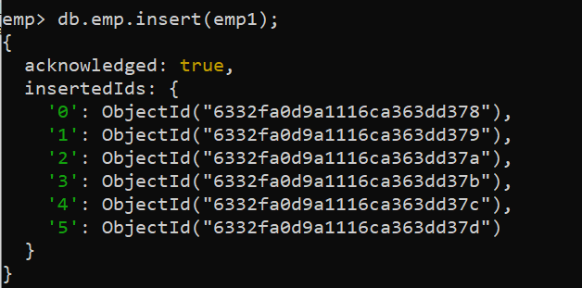

1. **Increase the Salary Of Employee where Name is ‘Tarun’ by 8000**

db.emp.find({"name.firstname":"Tarun"});

db.emp.update({"name.firstname":"Tarun"},{$inc:{salary:8000}});

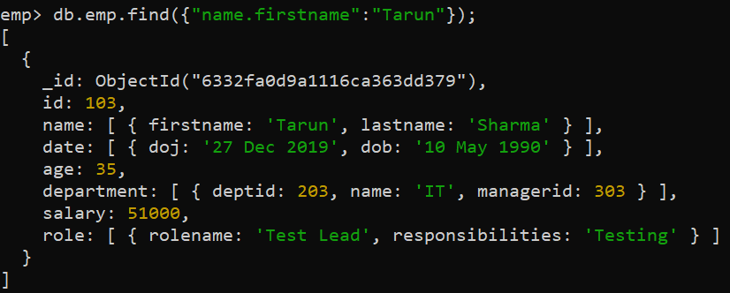

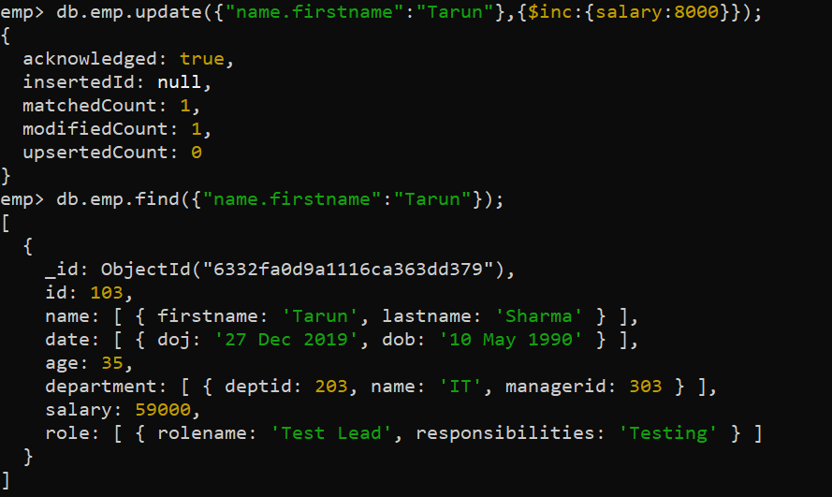

**2) update role of "data analyst" as "data scientist**"

db.emp.find({"role.rolename":"Data Analyst"});

db.emp.update({"role.rolename":"Data Analyst"},{$set:{"role.$.rolename":"Data Scientist"}});

db.emp.find({"role.rolename":"Data Scientist"});

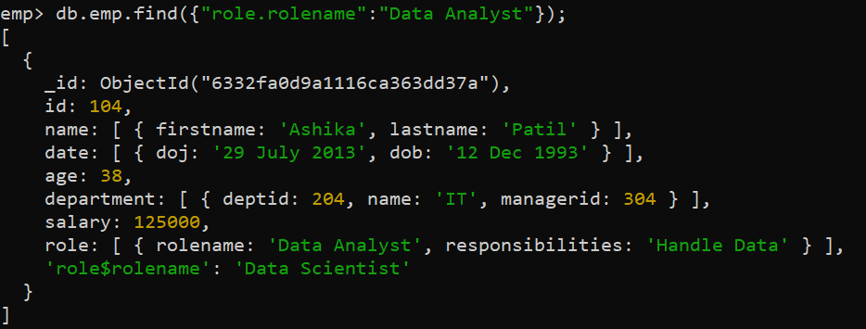

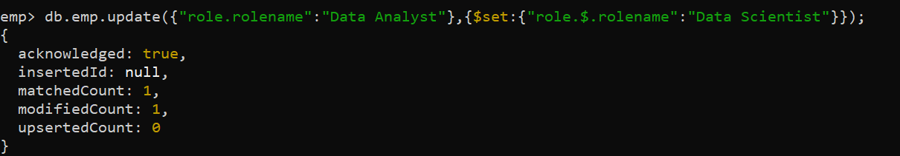

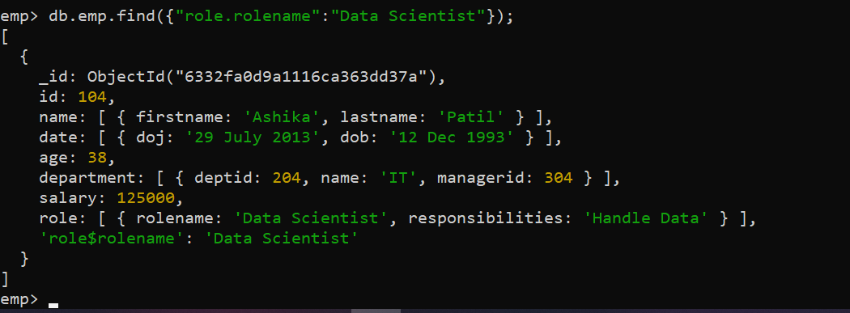

**3) Add a New Field remark to document with name "Sahil" set Remark as WFH**

db.emp.update({"name.firstname":"Sahil"},{$set:{Remark:"WFH"}},{upsert:false,multi:false});

db.emp.find({"name.firstname":"Sahil"});

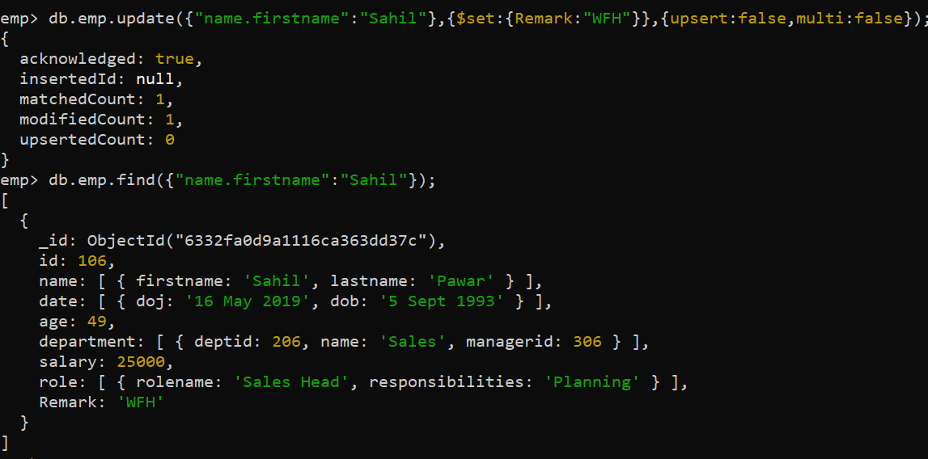

**4)Decrease the salary of ‘Mahesh’ by 2%.**

db.emp.find({"name.firstname":"Mahesh"});

db.emp.update({"name.firstname":"Mahesh"},{$mul:{salary:0.98}});

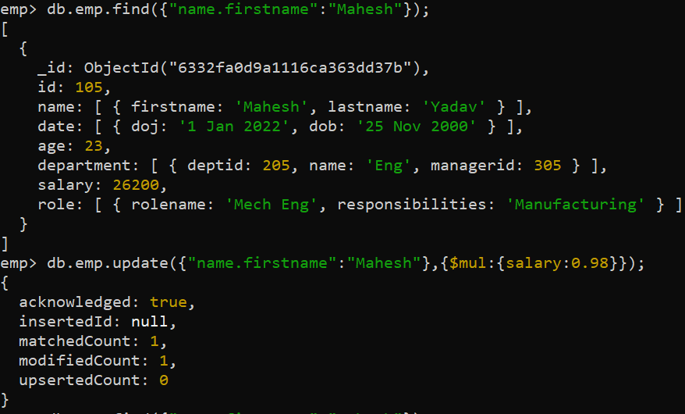

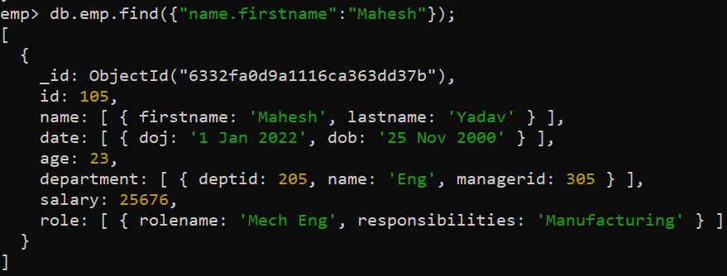

**5) Find Document from the emp collection where name begins with S**

db.emp.find({"name.firstname":/^S/});

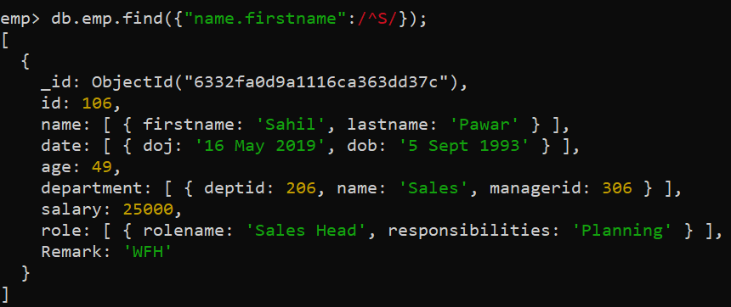

**6) Find Document from the EMPL collection where name begins with R and age more than 45.**

db.emp.find({$and:[{"name.firstname":/^R/},{"age":{$gt:40}}]});

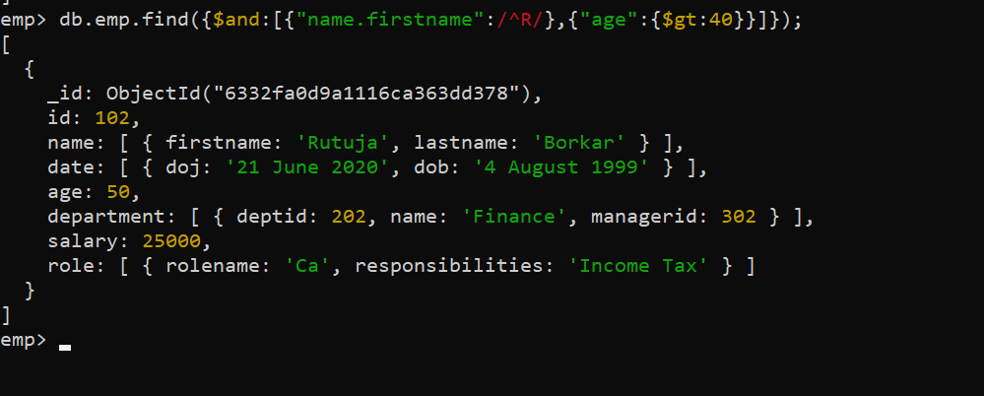

**7)To Find Document from the EMPL collection where name ends with K**

db.emp.find({"name.firstname":{$regex:"k$"}});

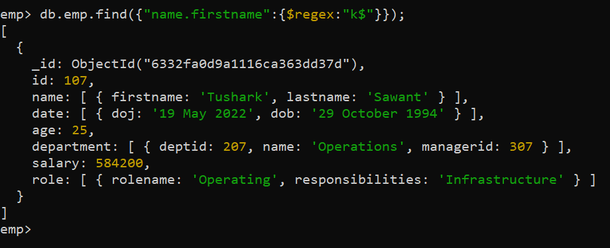

**8) Display employee Documents from Analytics and Finance department**

db.emp.find({"department.name":{$in:["Finance","Operations"]}});

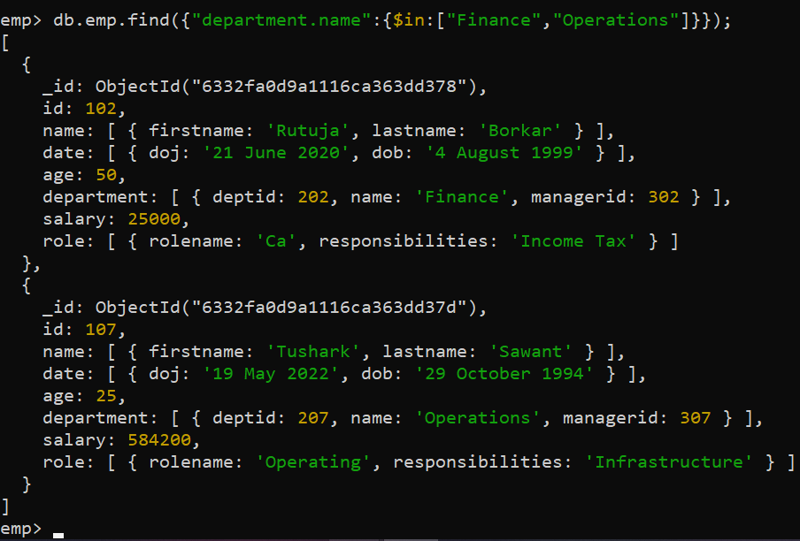

**9) Display the number of employees in each department.**

db.emp.find().count();

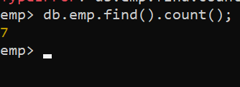

**10)Change the manager id of analytics department.**

db.emp.insert({"id":108,"name":[{"firstname":"Hrishi","lastname":"Gupta"}],"date":[{"doj":"19 Jan 2022","dob":"31 Dec 1999"}],"age":24,"department":[{"deptid":208,"name":"Analytics","managerid":308}],"salary":6500,"role":[{"rolename":"Data ","responsibilities":"manager"}]});

db.emp.update({"department.name":"Analytics"},{$set:{"department.$.managerid":309}});

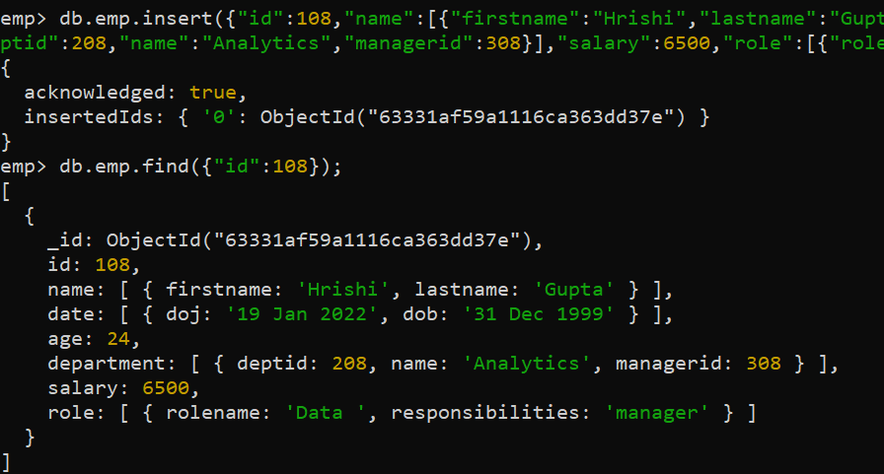

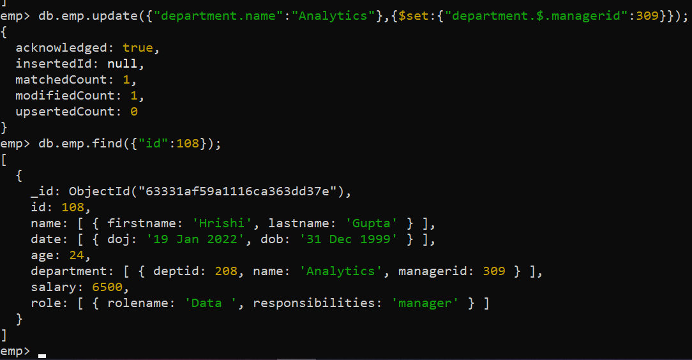

**11) Display the responsibilities of a particular employee in sales department.**

db.emp.find({"department.name":"Sales"},{"role.responsibilities":1});

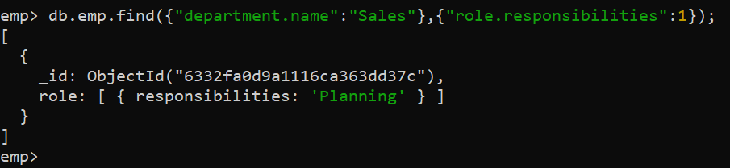

**12 )Find the average salary of Sales department**

db.emp.insert({"id":109,"name":[{"firstname":"Ishita","lastname":"Singh"}],"date":[{"doj":"19 Jan 2022","dob":"31 Dec 1999"}],"age":25,"department":[{"deptid":209,"name":"Sales","managerid":308}],"salary":65000,"role":[{"rolename":"Data ","responsibilities":"manager"}]});

db.emp.aggregate([

{$unwind:"$department"},

{$match:{"department.name":"Sales"}},

{$group:{_id:{

Department_Name:"$department.name"},

Average_Salary:{$avg:"$salary"}

}}]);

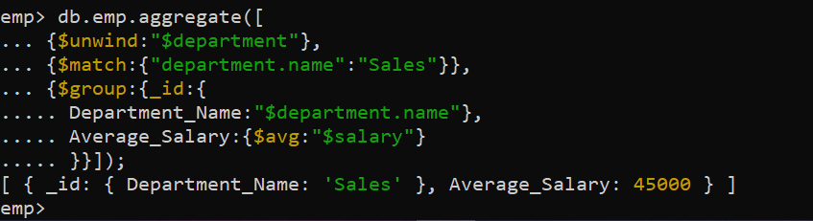

db.emp.aggregate([{$group:{_id:"$department.name",avg:{$avg:"$salary"}}}]);

